**BANK LOAN REPORT QUERY DOCUMENT**

1. **BANK LOAN REPORT | SUMMARY**

**KPI’s:**

1. **Total Loan Applications (KPI 1)**

select COUNT(id) as Total_Loan_Applications from financial_loan



**Month to Date Loan Application**

select COUNT(id) as Month_to_Date_Total_Loan_Applications from financial_loan

where month(issue_date) = 12 and year(issue_date) = 2021



**Previous Month to Date Loan Applications**

select COUNT(id) as Previous_Month_to_Date_Total_Loan_Applications from financial_loan

where month(issue_date) = 11 and year(issue_date) = 2021



1. **Total Funded Amount (KPI 2)**

Select sum(loan_amount) as Total_Funded_Amount from financial_loan



**Month to Date Total Funded Amount**

Select sum(loan_amount) as Month_To_Date_Total_Funded_Amount from financial_loan

where month(issue_date) = 12 and year(issue_date) = 2021



**Previous Month to Date Total Funded Amount**

Select sum(loan_amount) as Previous_Month_To_Date_Total_Funded_Amount from financial_loan

where month(issue_date) = 11 and year(issue_date) = 2021



1. **Total Amount Collected (KPI 3)**

Select sum(total_payment) as Total_Amount_Collected from financial_loan



**Month to Date Total Amount Collected**

Select sum(total_payment) as Month_to_date_Total_Amount_Collected from financial_loan

where month(issue_date) = 12 and year(issue_date) = 2021



**Previous Month to Date Total Amount Collected**

Select sum(total_payment) as Previous_Month_to_date_Total_Amount_Collected from financial_loan where month(issue_date) = 11 and year(issue_date) = 2021



1. **Average Interest Rate (KPI 4)**

select AVG(int_rate) * 100 as Avg_Interest_Rate from financial_loan



**Month to Date Avarage Interest Rate**

select AVG(int_rate) * 100 as MTD_Avg_Interest_Rate from financial_loan

where month(issue_date) = 12 and year(issue_date) = 2021



**Previous Month to Date Avarage Interest Rate**

select AVG(int_rate) * 100 as PMTD_Avg_Interest_Rate from financial_loan where month(issue_date) = 11 and year(issue_date) = 2021



1. **Avg DIT (KPI 5)**

select AVG(dti) * 100 as Avg_DTI from financial_loan



**Month to Date Avg DTI**

select AVG(dti) * 100 as MTD_Avg_DTI from financial_loan where MONTH(issue_date) = 12 and YEAR(issue_date) = 2021



**Previous Month to Date Avg DTI**

select AVG(dti) * 100 as PMTD_Avg_DTI from financial_loan

where MONTH(issue_date) = 11 and YEAR(issue_date) = 2021



**GOOD LOAN ISSUED**

**Good Loan Percentage**

select(count(case when loan_status = 'Fully Paid' or loan_status = 'Current' then id end) * 100) / count(id) as Good_Loan_Percentage from financial_loan



**Good Loan Applications**

select count(id) as Good_Loan_Applications from financial_loan

where loan_status = 'Fully Paid' or loan_status = 'Current'



**Good Loan Funded Amount**

select sum(loan_amount) as Good_Loan_Funded_Amount from financial_loan

where loan_status = 'Fully Paid' or loan_status = 'Current'



**Good Loan Total Received Amount**

select sum(total_payment) as Good_Loan_Received_Amount from financial_loan

where loan_status = 'Fully Paid' or loan_status = 'Current'



**BAD LOAN ISSUED**

**Bad Loan Application Percentage**

Select (count(case when loan_status = 'Charged Off' then id end) * 100)/ count(id) as Bad_Loan_Percentage from financial_loan



**Bad Loan Applications**

select COUNT(id) as Bad_loan_Applications from financial_loan

where loan_status = 'Charged Off'



**Bad Loan Funded Amount**

select SUM(loan_amount) as Bad_loan_Funded_Amount from financial_loan

where loan_status = 'Charged Off'



**Bad Loan Received Amount**

select SUM(total_payment) as Bad_loan_Received_Amount from financial_loan

where loan_status = 'Charged Off'



**LOAN STATUS**

Select

loan_status,

COUNT(id) as Total_Loan_Applications,

SUM(total_payment) as Total_Amount_Received,

SUM(loan_amount) as Total_Funded_Amount,

AVG(int_rate * 100) as Interest_Rate,

AVG(dti * 100) as DTI

from financial_loan

group by loan_status

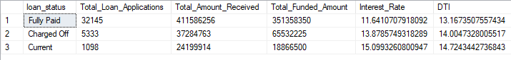

**Current Month**

select

loan_status,

SUM(total_payment) as MTD_Total_Loan_Amount_Received,

SUM(loan_amount) as MTD_Total_Funded_Amount

from financial_loan

where MONTH(issue_date) = 12

group by loan_status

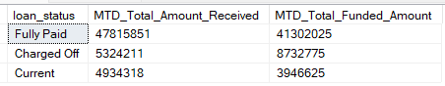

1. **BANK LOAN REPORT | OVERVIEW**

**MONTH**

select

MONTH(issue_date) as Month_Number,

DATENAME(MONTH, issue_date) as Month_Name,

COUNT(id) as Total_Loan_Applications,

SUM(loan_amount) as Total_Funded_Amount,

SUM(total_payment) as Total_Received_Amount

from financial_loan

group by Month(issue_date), DATENAME(MONTH, issue_date)

order by Month(issue_date)

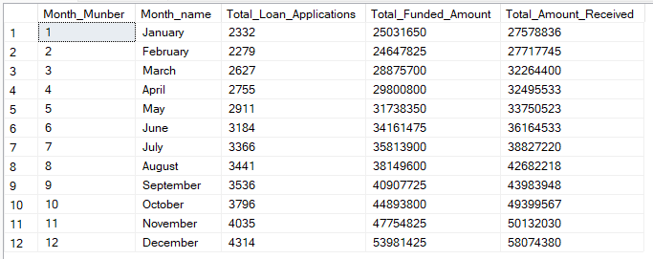

**STATE**

select

address_state,

COUNT(id) as Total_Loan_Applications,

SUM(loan_amount) as Total_Funded_Amount,

SUM(total_payment) as Total_Received_Amount

from financial_loan

group by address_state

order by address_state

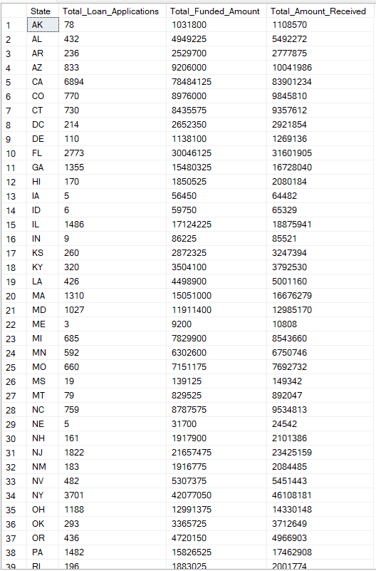

**TERM**

select

term,

COUNT(id) as Total_Loan_Applications,

SUM(loan_amount) as Total_Funded_Amount,

SUM(total_payment) as Total_Received_Amount

from financial_loan

group by term

order by term



**EMPLOYEE LENGTH**

select

emp_length,

COUNT(id) as Total_Loan_Applications,

SUM(loan_amount) as Total_Funded_Amount,

SUM(total_payment) as Total_Received_Amount

from financial_loan

group by emp_length

order by emp_length

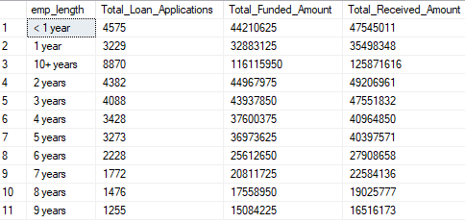

**PURPOSE**

select

purpose as Purpose,

COUNT(id) as Total_Loan_Applications,

SUM(loan_amount) as Total_Funded_Amount,

SUM(total_payment) as Total_Received_Amount

from financial_loan

group by purpose

order by purpose

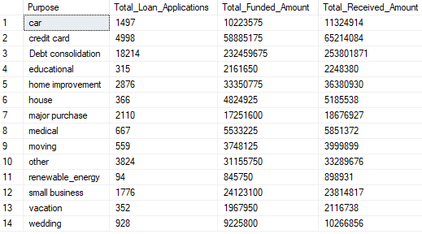

**HOME OWNERSHIP**

select

home_ownership as HOME_OWNERSHIP,

COUNT(id) as Total_Loan_Applications,

SUM(loan_amount) as Total_Funded_Amount,

SUM(total_payment) as Total_Received_Amount

from financial_loan

group by home_ownership

order by home_ownership

